UNIVERSITY OF THE FREE STATE
CSIS3724 | SOFTWARE ENGINEERING

UNIVERSITY SMART PARKING &
PERMIT MANAGEMENT SYSTEM
  - (USPMS)
SOFTWARE PROJECT MANAGEMENT PLAN
AND BUSINESS-LAYER DESIGN DOCUMENT

GROUP 16 - THE ARCHITECTS
Smarter Parking • Simpler Access • Better Campus Mobility
Lecturer / Client: Dr Tania Hill / University of the Free State
Prepared: 10 October 2026
Document edition: Consolidated final planning and design baseline
The document is written as a project baseline, not as proof of Blackboard submission, UFS approval, live external integration, or measured hours worked.

Document Control and How to Read This Edition
Field | Value
Project | University Smart Parking & Permit Management System (USPMS)
Team | Group 16 - The Architects
Module | CSIS3724 Software Engineering
Lecturer / client | Dr Tania Hill / University of the Free State
Version | 1.0 - Consolidated SPMP and business-layer design
Prepared date | 10 October 2026
Status | Final consolidated planning/design baseline; external approval and submission status are not asserted
Primary design approach | Responsive web application + business/application layer + relational persistence
Document rule | Arial 10 body text; hour-based project estimates; Iterative-and-Incremental Model; no separate test plan required

Team and documented role allocation
Team member | Student number | Role represented in project artefacts
Ashley Ashirai Hlatshwayo | 2025013596 | Group Leader
Anelisa Luxolo Rasi | 2025824075 | Project Manager and SPMP Coordinator
Oratile Thuto Moletsane | 2023013242 | Frontend and UI Designer
Katlego Motala | 2025007093 | Requirements Engineer and UML Designer
Kamogelo Andrew Marumo | 2023701549 | Business Analyst and UML Designer
Iviwe Faye | 2026135356 | Quality Assurance, Documentation and Cost Estimation Lead

Executive status
The project has a detailed preliminary specification, a nine-module use-case model, a cross-cutting requirement baseline and a design baseline. This delivery also includes a newly authored local reference prototype with automated domain/API tests (Appendix K). That prototype is a supplement prepared for this delivery; it is not claimed to be the historical application source developed by the team. The nine detailed modules are Digital Wallet, Permit Management, Smart Parking Guidance, Notifications and Alerts, Online Fine Payment, Accessibility Parking Support, Parking Zone Management, Visitor Parking Management and Occupancy Monitoring. The overall summary use case is a system-level narrative, not a tenth module.
The source portfolio describes the team’s intended/local prototype stack as React, TypeScript and Vite for the web UI; Node.js and Express for the API; Prisma for data access; and SQLite for local persistence. The source documents identify PeopleSoft, live payment, push/email/SMS, official map data and physical sensor/ANPR feeds as integration boundaries rather than live production integrations. The original GitHub repository snapshot contains five documentation files and no original application source tree, test suite or workflow configuration. A separate, newly authored reference implementation and test suite are included in this delivery pack and are explicitly distinguished from historical team implementation evidence in Appendix K.

Table of Contents
Section | Page
Document control and project team | 2
Table of Contents | 3
Chapter 1 — Project baseline and scope | 4
Chapter 3 — Software Project Management Plan | 5
Chapter 4 — Quotation | 13
Chapter 5 — Development effort overview | 14
Chapter 6 — Design documentation | 16
Chapter 7 — Record of hours spent | 20
Chapter 8 — Final portfolio assembly | 21
Appendix A — Requirements traceability and business rules | 22
Appendix B — Version history | 26
Appendix C — Decisions and design register | 27
Appendices D–E — Feedback and evidence registers | 28
Appendix F — Specification change register | 29
Appendix G — Glossary and status definitions | 30
Appendix H — Nine-use-case summary index | 31
Appendix I — Full-size editable diagrams | 33–38
Appendix J — Team-reported weekly hours register | 40–45
Appendix K — Supplemental reference implementation and test evidence | 46
Final submission readiness and evidence status | 47

Chapter 1 - Project Baseline and Scope

1.1 Problem and purpose
UFS campus parking is affected by increasing demand, limited physical capacity, difficulty discovering available spaces, permit administration effort, unauthorised parking, visitor coordination, enforcement work and a lack of connected availability information. USPMS is the proposed central software platform for connecting parking users, vehicles, permits, zones, occupancy, visitors, notifications and compliance records.

1.2 Project aim and success direction
The aim is to deliver a role-aware responsive web solution with an application/business layer and relational data storage. It must make parking rights and current or clearly labelled latest-known occupancy understandable, digitise permit and visitor workflows, improve notifications and keep privileged decisions traceable.
- Mandatory baseline: permit management, parking-zone management, visitor parking management, and notifications/alerts.
- Connected supporting modules from the existing nine-UML set: digital wallet, Smart Parking Guidance, fine/payment handling, accessibility parking support, occupancy monitoring, reporting and audit.
- Core safety constraint: an availability score, short walking distance or recommendation score can never override permit or temporary-credential authorisation.
- Initial build boundary: software-first. Manual/simulated occupancy is acceptable for prototype demonstration where approved physical data sources are not available; such data must not be described as live.
- Future integration boundaries: UFS PeopleSoft/approved institutional identity, production payment provider, email/SMS/push provider, official map/navigation data, IoT sensors, ANPR/video and physical gate/access-control systems.

1.3 Stakeholders and role boundaries
Stakeholder | Need / responsibility
Students | Register vehicles, apply for permits, view wallet/permit status, find authorised parking, receive alerts and view fines.
Academic and administrative staff | Use authorised parking and, where policy permits, host/pre-register visitors.
Visitors | Receive a limited guest workflow and temporary parking credential tied to approved visit details.
Parking Administrator | Review permit applications; manage zones, mappings and visitor allocation; operate authorised reports.
Protection Services | Verify vehicle/permit/zone context, record violations and handle enforcement and occupancy alerts within assigned permissions.
UFS Management | Use authorised aggregate dashboards and reports.
UFS identity / external providers | Provide identity, payment, route, notification or physical occupancy services only through approved interfaces.
Development team | Maintain requirements-to-design-to-code traceability, quality evidence, configuration control and hours records.

1.4 Documented scope exclusions
The initial software implementation does not depend on purchasing or installing sensors, ANPR cameras, boom gates or physical access hardware. Native Android/iOS applications are not a baseline dependency. UFS parking policy is not changed by USPMS; the application applies configured rules. Production SSO and payment integration require official access and approval. These boundaries preserve the mandatory brief without claiming unavailable integrations.

Chapter 3 - Software Project Management Plan (SPMP)

3.1 SPMP overview

3.1.1 Purpose
This SPMP establishes how Group 16 plans, develops, reviews, validates, controls and hands over USPMS. It is used by the project team and the lecturer/client as a common reference for responsibilities, estimates, iterations, quality, risk, changes and evidence. It is paired with the requirements specification and the business-layer design so that a decision in one artefact can be traced into the others.

3.1.2 Project summary
USPMS is a responsive web application with a distinct application/business layer and relational persistence. It connects permit and vehicle management, zone restrictions and mappings, visitor allocations, occupancy and availability, notifications, compliance, accessibility and reporting. The currently documented prototype stack is React/TypeScript/Vite, Node.js/Express, Prisma and SQLite. External production connections are not treated as live unless a verified integration test proves them.

3.1.3 Project scope baseline
The specification defines 35 functional requirements, 15 non-functional requirements and 31 cross-cutting business rules. The four minimum project-brief capabilities remain mandatory. The nine approved detailed UML modules remain UC-001 to UC-009, with the summary use case held separately at system level. Supporting scope is prioritised after the mandatory permit, zone, visitor and notification workflows are connected and validated.

3.1.4 Intended audience
The intended audience is Group 16, Dr Tania Hill/UFS as lecturer-client, reviewers assessing the deliverables and future maintainers who need to understand the business rules and integration boundaries.

3.1.5 Document organisation
This document retains the course portfolio numbering for the SPMP, quotation, iterative-development overview, design documentation, hours record and final assembly checklist. Appendices preserve requirement traceability, version history, decisions, feedback status, evidence references, the specification-change register and glossary.

3.1.6 SPMP evolution and version control
The baseline is version 1.0 dated 10 October 2026. Change requests are recorded, assessed for impact on requirements, design, data and tests, then approved by the project leader and affected owners. The implementation workspace is maintained outside the public GitHub documentation archive. No application commit or release history is asserted here. The initial and final specifications remain separate artefacts.

3.1.7 Reference artefacts
Reference | Use in this plan
CSIS3724 -Project -2026 -v0.pdf | Authoritative scope, submission rules, hourly estimate, quotation rate, model, design and formatting.
Hlatshwayo(2025013596)_G16_FirstPortfolio.pdf | Scope, requirements, business rules, documented prototype stack, nine-UML alignment and consistency checks.
USPMS_Merged_Use_Cases_COMPLETE_UC1_to_UC9.docx | Detailed UC-001 to UC-009 flows, alternatives, pre/postconditions and module boundaries.
Group_16_USPMS_SPMP_DRAFT_Submission.docx | Present in repository. Its DOCX text could not be reliably extracted, so this is not claimed as a word-for-word revision.
Assignment2_G16.pdf | Present in repository, but its binary text was unavailable in the current access path; no unverified requirements are attributed to it.
Group_16_USPMS_2026_Project_Working_Template.docx | Section coverage, appendices, hours-record layout and final team-check structure.

3.2 Assumptions and constraints

3.2.1 Grounded project assumptions
- Users have a web-enabled device and network access for live service functions.
- UFS will confirm the authoritative permit categories, eligibility rules, zone mappings, restrictions, capacities, visitor rules, retention rules and enforcement policy before production configuration.
- Seeded/demo accounts and simulated occupancy are used only to demonstrate software flows where live UFS and hardware access is unavailable.
- Students and staff authenticate through approved UFS/PeopleSoft identity services in production; USPMS does not store institutional passwords.
- Any production payment, mapping, notification or hardware connection must use an approved provider and a documented adapter/API.

3.2.2 Delivery constraints
- The CSIS3724 2026 brief is authoritative; assumptions cannot remove mandatory functionality.
- All planned durations are estimated in person-hours, and the project quotation includes testing, integration and other effort.
- The team must support remote, online and face-to-face work.
- UML specification/design focuses on business objects and domain interactions; it does not replace the UI or data-access implementation.
- No live production integration is claimed without source evidence. The 583-hour total in Chapter 7 is identified as team-reported and is not described as independently audited.

3.3 Project deliverables and exit criteria
Deliverable | Contents / acceptance condition | Evidence position in reviewed source set
Initial specification | Original scope and requirements baseline retained for comparison. | First preliminary portfolio PDF/DOCX variants exist in project artefacts.
Final specification | Refined 35 FR, 15 NFR, 31 business rules, 9 detailed UCs, consistency checks, glossary and change appendix. | Specification files are present; lecturer-feedback receipt is not present in the five-file GitHub tree.
SPMP | All management sections, hours, iteration strategy, DevOps, blended working, risk, quality and change controls. | This document supplies a complete consolidated baseline.
Quotation | Rate, hours, general expenses, VAT and total shown with transparent arithmetic. | Estimated baseline is calculated in Chapter 4; not a signed client quote.
Business-layer design | Business-class diagram, responsibilities, significant sequences, algorithms, technology choices and layer interaction. | Included in Chapter 6; editable diagrams are delivered separately.
Implementation / prototype | Runnable software for the nine workflows, with demo boundaries and role behaviour evidenced. | A separate newly authored local reference implementation is included in this delivery pack (Appendix K); it is not claimed as historical team source code.
Hours record | Requirements, specification/analysis, design, implementation, other and total; “Other” explained. | Team-reported 583-hour record is included in Chapter 7 and Appendix J; member confirmation and independent corroboration were not supplied.
Iteration overview | Increment-by-increment description, changes, lessons and what would be improved. | Chapter 5 and Appendix B/C/F distinguish artefact evidence from inferred chronology.
Final evidence index | Links/locations for source docs, design models, testing evidence and submission receipt. | Appendix E lists included evidence and items not present.

3.4 Effort estimate and schedule baseline
The 560-hour baseline remains the original planning estimate for full-scope work, including integration, validation and documentation. A 12-week, per-member time record was subsequently supplied by the team and is included in Chapter 7 and Appendix J. It totals 583 reported hours, a +23-hour variance (+4.1%) against the estimate. The supplied record is presented as team-reported data; it was not present in the inspected GitHub tree and has not been independently verified against calendar, meeting or time-tracking records.
Work category | Planned hours | Included activities
Requirements | 60 | Stakeholder/scope review, requirement clarification, actor flows, acceptance checks.
Specification / analysis | 105 | Business rules, detailed use cases, traceability, analysis models, feedback reconciliation.
Design | 80 | Business-layer classes, sequences, algorithms, architecture and technology rationale.
Implementation, integration and validation | 215 | Core features, data access, adapter boundaries, tests, integration checks, defect fixes and regression.
Other | 100 | Project coordination, blended-work overhead, DevOps/configuration, documentation, reviews, knowledge transfer and final assembly.
TOTAL | 560 | Planning baseline; an estimated 560-hour project baseline across the current six-member team; an equal split would average about 93.3 hours per member, but actual distribution is not asserted.

3.5 Iterative-and-Incremental development strategy
Every increment passes through requirements/analysis, design, implementation or refinement, verification, review, and retrospective. A requirement or design change is carried into later work with its original identifier retained. An increment is “done” only when its acceptance checks pass, its business-rule tests and integration evidence are recorded, its affected documents are updated and the changes are committed.
Increment | Hours | Primary goal and scope | Exit evidence
I0 - Inception and baseline | 65 | Confirm scope, actors, FR/NFR/BR baseline, source inventory, risks and initial business model. | Approved internal baseline; versioned requirement register; issue/risk owners recorded.
I1 - Identity, users, vehicles and permits | 90 | Role-aware demo/institutional boundary, vehicles, permit applications, decisions, status and validity. | Positive/negative eligibility tests; permit lifecycle flows; traceability updated.
I2 - Zones, mappings and occupancy | 95 | Zone configuration, capacity/restrictions, permit-zone authorisation, occupancy input/history/freshness. | Authorisation cannot be bypassed; boundary values and stale-data behaviour verified.
I3 - Visitor management | 90 | Host pre-registration, visitor bay search/allocation, temporary permit and cancellation. | Overlapping reservation rejection; correct credential limits; capacity released on cancellation.
I4 - Notifications, compliance and accessibility | 90 | In-app alerts/preferences, critical broadcasts, violations/fines, accessibility journeys and reports. | Failed non-critical delivery does not undo core transaction; role checks and audit tests pass.
I5 - Smart Parking Guidance and consolidation | 70 | Authorised-first filtering, suitability ranking, parking details and route boundary; cross-module integration. | No unauthorised recommendation; no-location and stale-source fallback cases verified.
I6 - Regression, documentation and handover | 60 | End-to-end regression, defects, accessibility/performance checks, diagrams, hours/quotation reconciliation and submission assembly. | Evidence index complete; only documented accepted limitations remain; final version tagged.
TOTAL | 560 | Relative effort schedule; hours are estimates, not calendar dates or actual elapsed time. | Across I0-I6

Feedback loop and definition of done
- Review feedback is logged with source, date, affected requirement, decision, owner and impacted artefacts; no feedback is silently discarded.
- Acceptance checks are derived from requirement IDs and business rules, not only from whether a page renders.
- Regression covers both the changed workflow and connected workflows whose statuses/data could be affected.
- Every iteration ends with a short retrospective: planned vs delivered, blockers, rework, risks, evidence links and actions for the next increment.

3.6 Development operations / DevOps plan
Control | Implementation rule | Evidence to retain
Version control | Use the GitHub repository as the source of truth. Work on a named branch per feature/defect; keep commits focused and descriptive. | Commit/PR links; branch/merge record; version tag per baseline.
Review | Require another team member to inspect business-rule and data changes before merge. High-risk permit, authorisation, payment, reservation and role changes need focused review. | PR review or documented review checklist.
Build and static checks | Run reproducible dependency install, production build, lint/type checks and available automated tests on each change. | Command output or CI run linked to commit.
Continuous integration | Add a GitHub Actions workflow for install, lint/type-check, test and build when code is present in repository. The five-file repository snapshot did not contain a workflow file. | Workflow YAML and green run per baseline.
Environment separation | Keep local/demo data separate from any UFS-approved environment; label simulated identity, payment and occupancy. | Environment notes, sample data provenance and integration flags.
Secrets | Use environment variables/secrets storage; never commit credentials, institutional passwords, private keys or real payment secrets. | Secret scan and documented configuration inventory.
Release and recovery | Tag candidate releases; back up the database used for demonstrations; rehearse a restore before final demo. | Tag, backup/restore checklist and recovery result.

The above DevOps controls are the project operating baseline for remaining implementation and final verification; their presence is not asserted as already configured in the current documentation-only GitHub tree.

3.7 Blended / remote working plan
Working mode | Operating method | Expected evidence
Remote / asynchronous | Use GitHub issues for ownership, blockers, acceptance criteria and due milestones; commit work in shared branches; place decisions in the repository rather than private chat only. | Issue/PR links and updated design/specification.
Online coordination | A short weekly synchronisation is planned, with an additional decision session before increment review. Share screen and record actions, not unnecessary personal meeting content. | Agenda, action owner, due effort estimate and completion state.
Face-to-face | Use in-person sessions for integrated demonstrations, whiteboard modelling and resolving cross-module conflicts when schedules allow. | Reviewed flow/diagram, attendance or action record where required.
Absence / blocker handling | Notify the group early, state blocked item and effect, reassign only after the owner agrees; keep changes small enough for another person to pick up. | Issue status and revised task ownership.
Knowledge sharing | Keep setup notes, domain definitions, API expectations, UML and decision log current; pair on risky business rules. | Reproducible setup instructions and reviewed handover.

3.8 Organisation, staffing and responsibilities

Role / owner | Primary accountability
Group Leader - Ashley Ashirai Hlatshwayo | Scope control, integrated delivery decisions, escalation and final readiness review.
Project Manager / SPMP Coordinator - Anelisa Luxolo Rasi | Maintain SPMP, iteration estimates, action log, effort/variance visibility and plan updates.
Frontend / UI Designer - Oratile Thuto Moletsane | Responsive interface flows, states, validation messages and UI-to-business-service contract.
Requirements Engineer / UML Designer - Katlego Motala | Requirement IDs, detailed use-case consistency, analysis UML and traceability.
Business Analyst / UML Designer - Kamogelo Andrew Marumo | Business objects, rules, actor responsibilities and domain workflow alignment.
QA / Documentation / Cost Estimation Lead - Iviwe Faye | Validation evidence, documentation consistency, quote arithmetic and acceptance checks.

3.9 Tools and resources
The documented prototype stack is React/TypeScript/Vite, Node.js/Express, Prisma and SQLite. Word holds the portfolio; Draw.io holds editable UML. The public GitHub repository contains project documentation only; the team reports that implementation work was completed outside that public repository. The source-code location is not specified in this document because a location or source link was not supplied. Each active contributor needs a development laptop, access to the team’s implementation workspace, the local toolchain and non-production test accounts/data.

3.10 Schedule, dependencies and estimation control
The hours baseline in section 3.4 estimates full-scope effort. The iteration table in section 3.5 is the relative schedule. The sequence is dependency-driven: identity/profile and vehicle records precede permit application; permit type and zone mappings precede authorised guidance; visitor request and allocation precede temporary credential; committed business events precede notification dispatch; and integrated feature completion precedes final regression/assembly. Every iteration review updates remaining hours and risks; estimates change only with a documented reason.

3.11 Risk management plan
Risk | Priority | Mitigation / trigger | Owner role
Wrong permit-zone configuration | High | Verify mappings against approved UFS policy; validate changes; test authorised and forbidden combinations. | Requirements + Business Analyst
Stale or incorrect occupancy | High | Persist source/time, compute bounds, expose stale/unknown state and avoid false live claims. | Occupancy/QA workstream
Reservation collision / double booking | High | Atomic reservation transaction, overlap query/constraint and conflict test. | Business-layer owner
Unauthorised role or action | High | Server-side RBAC, privileged-role provisioning, negative tests and audit event. | Group Leader + QA
External service unavailable | Medium | Adapter boundaries, simulation labels, retries for non-critical notification; no false payment success. | Integration owner
Unverified UFS policies/data | High | Keep configuration clearly demo-labelled; request institutional confirmation before production use. | Project Manager / Business Analyst
Scope expansion | High | Protect mandatory capabilities first; value-added chatbot and real hardware remain conditional/future. | Group Leader
No code/test/hours evidence in repository | High | Restore code and verification artefacts to source control; retain build/test logs and actual time sheets before final hand-in. | Project Manager + QA
Blended-team coordination gap | Medium | Issue ownership, shared decisions, weekly review and escalation of blockers. | Project Manager
Specification/design/code drift | High | Requirement IDs and change register; update related model and tests in same iteration. | Requirements + UML owners

3.12 Quality management plan
The course brief does not require a separate submitted test plan. Quality work remains mandatory throughout the lifecycle and is costed in this SPMP. Test cases should be recorded as evidence tied to requirement and business-rule IDs.
Quality activity | Minimum validation scope | Evidence
Requirements review | Every high-priority FR and mandatory brief feature maps to at least one use case, business object and acceptance check. | Review checklist and traceability update.
Unit/domain tests | Permit validity, role/authorisation policy, capacity bounds, reservation overlap, notification event, fine settlement and accessibility checks. | Automated result or documented repeatable test record.
Integration tests | UI/API/domain/persistence; status and audit commits; adapter failures; manual/simulated occupancy. | Request/response and state evidence.
End-to-end tests | Vehicle-to-permit; permit-to-authorised guidance; visitor pre-register-to-temporary permit/cancel; violation-to-fine-notification/payment result. | Screenshots, test log and defect references.
Negative/security tests | Wrong role, expired/suspended credential, closed zone, stale data, invalid capacity, duplicate payment callback and reservation collision. | Pass/fail plus defect/fix link.
Non-functional checks | Responsive layout, keyboard/labels/contrast, expected response targets, recoverability and supported browser smoke tests. | Measured result; numeric target exceptions explained.
Regression/release review | Repeat critical paths after changes and check setup/build reproducibility. | Commit-linked test record and release checklist.

3.12.7 Definition of done
- Acceptance criteria pass for the increment, including negative paths for security-sensitive rules.
- UI, API, business logic and persistence are consistent; transactions do not leave contradictory states.
- No live integration is claimed unless the target service was actually connected and tested.
- Design, traceability, change record and user-facing notes match the delivered behaviour.
- Changes are committed, reviewed, reproducible and linked to the corresponding verification record.

3.13 Requirements management and change control
A change request includes its origin, affected requirement/business rule/use case, reason, urgency, behavioural and data impact, security/accessibility effect, estimate in hours, test impact and decision owner. The Requirements Engineer updates the baseline; the Business Analyst/UML owner updates use cases and diagrams; the relevant developer updates implementation; QA updates acceptance/regression evidence; the SPMP coordinator updates estimates and the iteration record. Existing requirement IDs are retained unless a requirement is genuinely retired, and retirement needs a documented rationale that preserves mandatory scope.

3.14 Configuration management plan
Version-control the specification, SPMP, design source, code, database schema/migrations, sample/demo data, test scripts, test evidence and release notes. Exclude environment secrets, private credentials, personal data and build output. Use consistent names, keep the initial specification and final specification separately, and label diagrams/files with version and date. A release tag refers to the exact code and documentation baseline demonstrated.

3.15 Issue and problem management plan
Every defect/blocker is logged with a unique ID, observed behaviour, expected behaviour, reproduction steps, affected requirement, severity, impact and owner. Triage order is: security/authorisation or data-integrity defect; mandatory workflow failure; integration/availability failure; usability/accessibility issue; low-impact enhancement. A defect closes only after a reproducible fix and regression result are linked; unresolved limitations are stated in the release notes.

3.16 Communication and reporting plan
Event | Cadence / trigger | Output
Team synchronisation | Weekly planned online meeting; additional meeting for increment review or high-risk design decision. | Decisions, action owners, blocker escalation and effort changes.
Increment review | At each increment end. | Demonstration, acceptance outcomes, defects, change list and next increment entry criteria.
Lecturer/client review | At each requested submission/review milestone. | Feedback log tied to source and a specification change record.
Risk escalation | As soon as impact could threaten mandatory features, data integrity or submission. | Issue raised to Group Leader and affected owner; mitigation and decision recorded.
Repository updates | For every merged change or approved document baseline. | Commit/PR reference and updated evidence index.

3.17 Training and knowledge transfer
Each technical owner documents local setup, dependency install, environment configuration without secrets, domain rules, route/service contracts and the relevant verification command. For permit, visitor reservation, occupancy and payment-state logic, a second member reviews the workflow and is able to reproduce its expected success and failure cases. Handover includes architecture/class diagrams, schema/migration instructions, data provenance, known integration boundaries and recovery steps.

3.18 Maintenance and support approach
Corrective maintenance fixes defects; adaptive maintenance adjusts approved UFS policy/configuration or external provider contracts; perfective maintenance improves performance, accessibility and reporting without weakening authorisation rules. Security-sensitive changes receive regression checks. Local demo data and production data must remain separated. Data retention and deletion periods follow UFS-approved policy rather than an invented retention period.

3.19 Security and privacy management approach
- Keep institutional credentials within UFS/approved identity services; store only the identity reference and parking-profile attributes required.
- Enforce permissions server-side; validate inputs and re-check permit status, zone status, accessibility eligibility and reservation conflicts at transaction time.
- Minimise visitor/vehicle data, role-scope screens and reports, and follow POPIA-aligned handling plus UFS-approved retention/deletion policy.
- Keep secrets outside source and screenshots; protect environment/repository configuration and use non-production test accounts.
- Append privileged/business-transition audit events without unnecessary sensitive payloads. A fine is paid only after verified success or authorised settlement; reject duplicate callbacks idempotently.

3.20 Process improvement plan
At every retrospective, compare estimate to outcome when actual hours become available; identify rework sources, missed dependencies, requirement drift and defect leakage; assign one measurable action to the next iteration; and check the action at the next review. Improvement decisions are stored in Appendix C and affect subsequent estimates, checklists and definition-of-done criteria.

3.21 SPMP conclusion
The plan establishes incremental delivery, the original 560-hour estimate, the subsequent 583 team-reported hours, blended work, risk and quality controls, and links between requirements, design, implementation and verification. Completion claims remain limited to available evidence.

Chapter 4 - Quotation for the System
This quotation is an estimated full-scope cost baseline prepared using the prescribed course rates. The calculation includes integration and testing effort. It is not represented as an invoice, a signed acceptance or an approved production procurement amount.

4.1 Cost calculation
Cost item | Calculation | Amount
Estimated person-hours | Requirements 60 + specification/analysis 105 + design 80 + implementation/integration/validation 215 + other 100 | 560 hours
Labour subtotal | 560 hours × R350 per hour | R196,000.00
General expenses | 5% × R196,000.00 | R9,800.00
Subtotal before VAT | R196,000.00 + R9,800.00 | R205,800.00
VAT | 15% × R205,800.00 | R30,870.00
TOTAL ESTIMATED QUOTATION | R205,800.00 + R30,870.00 | R236,670.00

4.2 Quotation basis and exclusions
The labour rate is the CSIS3724 brief rate of R350 per team-member hour. The original 560-hour estimate covers the full scoped project across six team members, with 5% general expenses and 15% VAT applied in the prescribed order. A subsequent team-reported log totals 583 hours; its individual/category breakdown is in Chapter 7 and Appendix J. The retrospective cost equivalent at the same rate is R246,390.38, shown separately from the original estimated quotation of R236,670.00. External service subscription, hardware procurement, real UFS integration costs and post-semester operational hosting are excluded because approved supplier prices were not supplied.

4.3 Estimate reconciliation rule
The supplied record reports 583 hours against the original 560-hour estimate, a +23-hour (+4.1%) variance. Category variances are Requirements -13 hours, Specification/Analysis -10 hours, Design +17 hours, Implementation -21 hours and Other +50 hours. The main reported variance is in Other; the team should review the task categorisation and supporting records. Do not change historical hours to force agreement with the estimate, and do not replace the original quotation baseline with the retrospective cost equivalent.

Chapter 5 - Overview of Development Effort and Iterative-and-Incremental Model

5.1 Model selected
The required Iterative-and-Incremental Model fits USPMS because identity, permits and zone authorisation are foundations for later visitor allocation, occupancy guidance, alerts and compliance. Requirements, class design, implementation and validation must evolve together across increments instead of being treated as one large sequence performed only once.

5.2 Evidence of iteration in the artefact set
Documented artefact | What it contributes to the iteration history | Limit of the evidence
First preliminary project portfolio | Initial scope/problem framing, requirements, actors, nine UML models and prototype alignment. | The artefact is labelled preliminary; it is not proof of lecturer approval.
Revised nine-UML specification | Refines the detailed UC-001 to UC-009 mapping, functional/non-functional requirements, business rules and traceability/consistency checks. | No lecturer feedback log is included in the repository snapshot, so individual changes are not falsely attributed to lecturer feedback.
Merged UC-001 to UC-009 document | Preserves detailed flow/scenario material for nine modules and a summary use case. | Some sections refer to UI evidence panels; final submission should ensure any referenced screenshot is actually present.
SPMP draft in repository | Shows the project-management plan was a separate artefact in progress. | The public repository is a documentation archive and does not show the application’s development history. Draft material is not silently treated as fully reconciled.
This consolidated edition | Completes the SPMP/design content against the authoritative brief and re-lists existing work in traceability/change/evidence appendices. | Planning estimates and newly authored design assets are flagged in the companion audit.

5.3 Increment review and change loop
- Baseline requirements and rules are versioned before a feature increment begins.
- Design operations are reviewed against a specific UC and requirement IDs.
- Implementation is validated against success, alternative and failure flows before review.
- Cross-module regression follows any change to a shared object, identity rule, permit/zone mapping, occupancy state, notification trigger or audit event.
- Review decisions update the change register and the effort estimate for the next iteration.

5.4 What the artefact trail indicates
The strongest directly reviewable artefacts are the requirements/specification, nine-use-case model, business rules and design baseline. The public GitHub repository is being used as a documentation archive, not as the project execution repository; the team reports that implementation work was completed and retained outside GitHub. The supplied weekly record reports React/TypeScript/Vite UI work, Node/Express API work, Prisma/SQLite data work, integration and testing activities. Because the underlying off-repository source/build files and raw test output were not included in the reviewed evidence set, this retrospective uses numbered project-part references and artefact names rather than Git commit IDs. It does not invent numerical test pass counts.

5.5 Lessons and what to improve on a similar project
Lesson | Improvement action
Keep requirement, UML, code and evidence synchronized. | Maintain Appendix A traceability continuously; avoid postponing consistency review until final assembly.
Authorisation must precede availability ranking. | Implement the rule as a reusable domain policy and test it in every entry point, not merely the parking UI.
External systems introduce uncontrolled dependencies. | Design adapters and simulations early; separate demo/test status from live status in UI and documentation.
A design-only repository makes verification difficult. | Keep implementation, migration/configuration instructions, test assets and verification evidence together in the team’s controlled project location; use source control where it was used for the actual application.
Hours and feedback are process evidence. | Log hours and client feedback at the time work occurs; reconstructing these retrospectively is less reliable.

5.6 Actual Iteration History and Retrospective
This retrospective uses Parts 1–6 as stable references, not Git commits or release IDs. The periods follow the team’s weekly record (23 July–10 October 2026); phase groupings are reconstructed from those entries and available artefacts. The team reports implementation was completed outside the public GitHub documentation archive. Test counts are not claimed without result records.
Project-part reference and period | Focus and work recorded | Artefact reference and retrospective outcome
Part 1 — Inception and requirements baseline  23 Jul–02 Aug 2026 (W1–W2) | Kickoff; scope and stakeholders; problem statement; initial FR/NFR; domain vocabulary; assumptions, constraints and risk baseline. | Refs: Chapter 1; Appendix J W1–W2. Outcome: scope and requirements baseline documented; approval date not evidenced.
Part 2 — Specification and analysis  03–16 Aug 2026 (W3–W4) | FR/NFR review; actors; nine detailed use-case modules; scenarios, pre/postconditions and business-rule consistency. | Refs: First Portfolio; merged UC-001–UC-009; Chapters 1–2; Appendix J W3–W4. Outcome: nine cases and rules documented; no dated lecturer approval claimed.
Part 3 — Design baseline  17 Aug–06 Sep 2026 (W5–W7) | Logical architecture; business class model; UI/use-case mapping; sequence flows, typed attributes, associations, multiplicities and algorithms. | Refs: Chapter 6; Appendix I; Draw.io source; Appendix J W5–W7. Revised editable diagrams are included; this is not a historical release ID.
Part 4 — Implementation and initial integration  07–20 Sep 2026 (W8–W9) | Team log reports UI setup, Node/Express API, permit/guidance logic, database migrations, API contracts and external adapters. | Refs: Appendix J W8–W9; Chapters 3/6. The team reports implementation outside the public GitHub archive; source/build files were not included here, so no build ID is claimed.
Part 5 — Feature integration and verification  21 Sep–04 Oct 2026 (W10–W11) | Team log reports fine/payment and notifications, integrity constraints, unit/negative/manual/regression tests, accessibility and traceability checks. | Refs: Appendix J W10–W11; traceability matrix. Testing activity is reported, but detailed execution reports and pass counts were not supplied.
Part 6 — Portfolio and close-out  05–10 Oct 2026 (W12) | Final SPMP, effort overview, design chapter, UI screenshots, evidence index, portfolio and final formatting QA. | Refs: Appendix J W12; Chapters 3–8; Appendices I–K. Documentation pack assembled; no submission receipt or lecturer sign-off is claimed.
These are retrospective cross-reference labels derived from the supplied weekly records and artefacts. They are not Git commits, release tags or formal sign-off events.

Chapter 6 - Design Documentation

6.1 Design introduction and scope
This design describes the business/application layer of USPMS. In keeping with the course brief, UML class responsibilities and important business interactions are the focus. The presentation layer and data access layer are shown only to explain their boundary with business objects. Complex workflows are detailed only where domain safety or transactional consistency requires it.

6.2 Design principles
- Business rules are centralized in domain services/policies, not duplicated in UI controls.
- Authorisation is a hard eligibility filter and runs before any Smart Parking Assistant ranking.
- Multi-record permit, reservation, fine and audit state changes are committed consistently.
- External identity, payment, navigation, notifications and physical occupancy are accessed through adapters and can fail independently.
- Demo/simulated information is explicitly marked; source freshness is visible whenever occupancy is displayed.
- Business objects hold domain state/behaviour and do not directly depend on React components or Prisma details.

6.3 Candidate business objects and responsibilities
Business object | Responsibility and central relationships
User / Role | Parking profile linked to external identity reference, status and assigned roles. Owns vehicles; applies for permits; hosts visitor requests; receives notifications.
Vehicle | Normalised registration and status; belongs to a user profile; associated with permits and compliance records.
PermitType | Institutional permit category, eligibility policy and authorised-zone mappings.
ParkingPermit | Vehicle/user-specific status and validity with application/review/renewal/suspend/revoke/reinstate lifecycle.
ParkingZone | Zone identity, intended use, capacity, restrictions, active/closed status and reserved resource model.
PermitZoneAuthorisation | Associates a permit type with a parking zone; used as a hard constraint for guidance and allocation.
OccupancySnapshot / OccupancyEvent | Occupied count, source, timestamp and freshness; validates values and supports history/alerts.
VisitorRequest / Visitor | Host, visitor category, vehicle, purpose, time window and request/allocation status.
Reservation | Time-window allocation of a bay/resource with conflict checking and cancellation/expiry transitions.
TemporaryPermit | Guest credential tied to a visitor/vehicle, validity window and approved zone/bay.
Notification | Committed event, recipient, channel/preference, delivery state and retry result.
Violation | Enforcement event linked to vehicle, zone, time and supporting evidence reference.
Fine / Payment | Financial amount and status; fine is settled only on confirmed successful payment or authorised settlement.
Accessibility entitlement/request | Minimum status needed to support authorised accessible-parking decisions without unnecessary health-detail storage.
AuditEvent | Append-only trace: actor, action, object reference and time.

6.4 Business-layer class model
The model below consolidates the existing domain vocabulary into a business-object view. It does not imply that every object is implemented as a separate physical database table; persistence mapping belongs to the data-access design.
Figure 6.1. The full-size editable business-layer model is reproduced in Appendix I, Figure I.2, with supporting business objects in Figure I.3.

6.5 Key class responsibilities and invariants
Class / service | Operations or responsibility | Invariant
PermitService / ParkingPermit | Validate eligibility, create application, record decision and renew/suspend/revoke/reinstate. | Only valid active permits authorise the configured type/vehicle/time window.
ZonePolicy / ParkingZone | Manage capacity, restrictions, status and permitted uses. | Closed/inactive zones are excluded; occupied count must stay between zero and capacity.
AuthorisationPolicy | Resolve the active permit or temporary credential and permitted zone set. | Never return an unauthorised zone as an allowed destination.
OccupancyService | Ingest manual/simulated/source readings, validate, timestamp and maintain history. | Invalid counts are rejected; stale/unknown status is not presented as live.
ReservationService | Check overlaps and allocate/cancel/expire resources within a transaction. | No overlapping active reservations for the same resource/time range.
TemporaryPermitService | Issue credential after successful visitor allocation. | Credential is bound to the visitor/vehicle, zone/bay and approved period.
NotificationService | Consume committed events and record channel delivery state/retries. | Failed non-critical dispatch does not roll back the underlying business transaction.
FinePaymentService | Create fine from a validated violation and reconcile payment status. | A fine is never marked paid on a client-side success message alone.
AuditService | Append selected actor/action/object/timestamp records. | Ordinary users cannot change privileged audit history.

6.6 Sequence design: permit lifecycle
Figure 6.2. Full-size UML sequence diagram: Appendix I, Figure I.4. Permit status and audit events are persisted before notification delivery is queued.
The permit workflow starts with a registered vehicle and validated user profile. Application submission creates a pending record. An authorised administrator records approve/reject and validity details; the status and audit record are committed together. The notification is then queued from the committed event. Failure to send the notification does not reverse a permit decision.

6.7 Sequence design: visitor allocation and cancellation
Figure 6.3. Full-size UML sequence diagram: Appendix I, Figure I.5. Temporary credentials are issued only after successful allocation.
A host or administrator creates a time-bounded visitor request. ReservationService rechecks bay availability and overlapping reservations at commit time. A temporary credential is created only after reservation succeeds and is limited to the approved visit window and zone/bay. Cancellation marks the reservation cancelled and releases capacity in the same transaction, with an audit event and follow-up notification.

6.8 Sequence design: authorised-first Smart Parking Guidance
Figure 6.4. Full-size UML sequence diagram: Appendix I, Figure I.6. Authorisation is checked before occupancy data is ranked.
The guidance sequence rejects the unsafe pattern of retrieving all available zones and ranking them before checking permission. Instead, it resolves an active permit/temporary credential, retrieves only permitted zone mappings, removes closed/restricted/incompatible zones, then evaluates occupancy and freshness. A result can disclose that data is stale or location is unavailable; neither condition allows an unauthorised zone to be recommended.

6.9 Complex calculations and algorithms

6.9.1 Smart Parking Assistant candidate selection
1. Authenticate the user and resolve the active permit or temporary visitor credential and its validity window.
2. Load permit-type-to-zone authorisations. If no active credential or permitted zone exists, return a clear no-authorised-option message.
3. Filter out zones that are closed, inactive, restricted for the user, full, incompatible with accessibility needs or otherwise unavailable.
4. For each remaining zone, calculate available capacity from the latest valid occupancy snapshot and expose source/timestamp freshness. Reject impossible occupancy values.
5. Rank only the eligible set. For the documented baseline, sort by descending availability, then ascending walking distance when distance is available, then stable zone identifier as a tie-break. Do not use this order to bypass any hard authorisation rule.
6. If all occupancy readings are stale or missing, report data freshness/uncertainty and show only what the approved stale-data policy permits. Do not claim a stale reading is live.
7. Before finalising the choice/route, recheck current authorisation and availability where the workflow performs a reservation or commits a destination.
The ordering rule above is a concrete deterministic design choice for this consolidated baseline; the companion audit identifies it as newly authored and recommends validation against the lecturer/client’s preferred ranking behaviour. Numeric score weights are deliberately not invented.

6.9.2 Reservation conflict check
For a requested resource and time window [start, end), an existing active reservation conflicts if existing.start < requested.end and existing.end > requested.start. The service re-evaluates conflicts inside the reservation transaction, creates the reservation only if the result is conflict-free, and commits reservation plus audit state together. Cancellation/expiry updates the state and releases reserved capacity as one transaction.

6.9.3 Fine payment state
A payment attempt begins in a pending/initiated state. The business layer accepts only a verified provider result or authorised administrative settlement. Success updates payment and fine state idempotently; decline, timeout or provider outage leaves the fine outstanding and records the failure. Duplicate callbacks must not create duplicate settlements.

6.10 System architecture and layer interaction
Figure 6.5. Full-size logical architecture: Appendix I, Figure I.1. External systems are integration boundaries, not claims of live deployment.
The responsive UI sends requests to the Express API. API handlers authenticate/resolve role-aware sessions and invoke domain services. Domain services enforce permit, zone, visitor, occupancy, notification and compliance rules; repositories implemented through Prisma persist state to SQLite in the local prototype. Business objects do not call UI controls or directly depend on data-access APIs. Adapters isolate PeopleSoft, payment, mapping, notification and hardware sources; a failed optional provider must not corrupt core parking state.

6.11 Technology selection
Technology / decision | Rationale and project boundary
Responsive online web application | Users include students, staff, visitors, administrators and Protection Services across desktop and mobile browsers. A central service avoids separate native-client builds for the baseline.
React + TypeScript + Vite | Recorded in the existing portfolio as the current local prototype UI stack; supports modular route-based user workflows and type-checked client code.
Node.js + Express | Recorded in the portfolio as the local API/business-service host; separates browser presentation from server-enforced rules.
Prisma | Recorded in the portfolio as the data-access adapter/ORM, keeping persistence calls out of business-facing UI code.
SQLite | Recorded as local prototype persistence. A production datastore choice and hosting design require institutional deployment constraints and operational approval; this plan does not quietly replace the documented prototype database.
Draw.io / Microsoft Word / GitHub | Editable UML source, required editable submission format and source-control/evidence location respectively.

6.12 Online vs Windows-based system
USPMS is designed as an online, responsive web system rather than a Windows-only desktop application. It needs to serve multiple campus roles without installing a native application and requires a shared business/data source for current permits, zone mappings, reservations and occupancy. The documented local prototype can be run in a local development environment; that does not mean a production online service is already deployed.

6.13 Security, privacy and failure handling
Concern | Design response
Institutional login | Delegate credential validation to UFS PeopleSoft/approved identity; persist identity reference, not the password.
Role boundaries | Enforce every privileged action server-side, with authorised provisioning and audit records.
Stale occupancy | Show source/time freshness; keep stale or unknown states explicit; filter impossible occupancy values.
Payment and notification outages | Isolate adapters; only confirmed payment settles a fine; notification failure does not roll back a committed business operation.
Reservation races | Recheck conflicts in a transaction and make cancellation/release atomic.
Accessibility and sensitive data | Store the minimum entitlement/status needed; do not require unnecessary medical details.
Audit and retention | Append audit entries for protected events; apply the UFS-approved retention policy when defined.

6.14 Design traceability
Appendix A maps each FR-001 to FR-035 identifier to the existing UC-001 to UC-009 catalogue. The key cross-cutting design mappings are: identity/RBAC to User/Role and all use cases; permit validity and decisions to ParkingPermit/PermitType; authorised guidance to PermitZoneAuthorisation/ParkingZone/OccupancySnapshot; visitor allocation to VisitorRequest/Reservation/TemporaryPermit; committed events to Notification; compliance to Violation/Fine/Payment; and protected transitions to AuditEvent.

6.15 Design conclusion
The design supports the documented software-first prototype and preserves the critical business constraints: valid identity and roles, permit/zone authorisation before guidance, freshness-aware occupancy, conflict-safe reservation, time-bounded visitor credentials, confirmed payment outcomes and traceable privileged actions. The editable diagram source delivered with this document contains the architecture, business-class model and three key sequence models.

Chapter 7 - Record of Hours Spent
The CSIS3724 brief requires hours to be recorded in five categories. The original planning estimate is 560 hours. The team subsequently supplied a 12-week record with per-member weekly activity descriptions; the supplied entries sum to 583 hours. This record is reproduced in Appendix J and summarised below. It is labelled team-reported because the log was supplied in this conversation rather than committed to the inspected GitHub tree, and no independent timesheet export or member sign-off was supplied.
Category | Planned hours | Reported actual hours | Variance (actual - plan)
Requirements | 60 | 47 | -13
Specification / Analysis | 105 | 95 | -10
Design | 80 | 97 | +17
Implementation, integration and validation | 215 | 194 | -21
Other | 100 | 150 | +50
TOTAL | 560 | 583 | +23 (+4.1%)
Current team member | Role | Reported total hours
Ashley Ashirai Hlatshwayo | Group Leader | 105
Anelisa Luxolo Rasi | Project Manager & SPMP Coordinator | 98
Oratile Thuto Moletsane | Frontend & UI Designer | 95
Katlego Motala | Requirements Engineer & UML Designer | 95
Kamogelo Andrew Marumo | Business Analyst & UML Designer | 95
Iviwe Faye | QA, Documentation & Cost Estimation Lead | 95
TOTAL | Six current members | 583
Record status: the entries are reproduced from the team-provided 12-week record. Totals reconcile arithmetically. This document does not claim that the log was independently audited or signed by every member. See Appendix J for weekly details and the companion audit for the remaining verification items.

7.1 What counts as “Other”
Other covers the entries the team categorised as project planning and administration, meetings and coordination, repository/configuration work, knowledge transfer, portfolio assembly and supporting documentation. The team-reported record assigns 150 hours to Other against the original estimate of 100 hours. The team should retain the original category as recorded, then confirm that each activity belongs in Other rather than reclassifying hours simply to reduce the variance.

7.2 How to maintain the actual record
Appendix J preserves the 12 weekly entries provided for each of the six current team members, including the reported day/session pattern, category, hours and task description. The overall total is 583 hours. Before treating it as an official signed-off record, the Project Manager should have all six members confirm their entries and retain any contemporaneous supporting evidence. Iviwe Faye’s W12 entry specifies 9 hours under Other but the supplied text does not state the task; that limitation is shown in the log and the audit rather than inferred.

Chapter 8 - Final Portfolio Assembly and Submission Checklist
Artefact / control | Status from reviewed evidence | Close-out criterion
Initial specification | Existing preliminary specification artefact found. | Retain it separately and submit with final specification when required.
Final specification | Nine detailed use cases, requirement baseline and consistency checks are documented in the available specification artefact set. | Reconcile all lecturer feedback and ensure change appendix corresponds to the final version.
SPMP | This document supplies the consolidated SPMP baseline. | Team review and confirm any policy/effort changes before Blackboard submission.
Quotation | Calculated estimate included in Chapter 4. | Review estimate assumptions; identify it as estimate until formally accepted.
Design documentation | Business classes, sequences, algorithm rules, layers and technology rationale included. | Keep editable Draw.io source with document and validate diagram alignment against current implementation.
Prototype/source code | Existing portfolio describes a local prototype; no application source appears in the reviewed GitHub tree. | Restore/attach the actual code repository and reproducible setup/build evidence.
Testing evidence | No code test logs/CI run evidence found in the five-file GitHub tree. | Run and retain unit, integration, negative/security, accessibility and end-to-end evidence.
Hours record | The team-provided weekly record is incorporated in Chapter 7 and Appendix J; reported total is 583 hours. | Confirm each member’s entries, retain supporting records where available, and retain member confirmation of Iviwe Faye’s W12 task description.
Meeting/feedback evidence | No dated minutes or lecturer feedback log included in the five-file repository snapshot. | Add actual records where they exist and map resulting changes in Appendix F.
Final naming / format | Word document prepared in Arial 10 body text. | Use the filename convention specified by the module and submit the required editable .docx.
Submission receipt | Not included in the reviewed repository snapshot. | Retain Blackboard submission confirmation separately.

Completion principle
A portfolio item is complete when the artefact exists, its contents match the approved baseline, it has a source/version reference, and the evidence needed to support any completion claim is available. A written description of a prototype, integration or test is not treated as equivalent to its runnable source or actual execution record.

Appendix A - Functional Requirements to Use-Case Traceability
The identifiers and primary mappings below preserve the mapping from the revised specification. The summary use case is cross-cutting; the nine detailed UML modules remain UC-001 to UC-009.
Requirement ID | Requirement name | Detailed UML coverage
FR-001 | Institutional / visitor authentication | Summary/shared; all UCs
FR-002 | Role-based access | Summary/shared; all UCs
FR-003 | Identity linkage and visitor provisioning | Summary/shared; UC-008
FR-004 | Vehicle registration | UC-002
FR-005 | Permit application | UC-002
FR-006 | Permit review | UC-002
FR-007 | Permit decision | UC-002
FR-008 | Permit renewal and validity | UC-001, UC-002
FR-009 | Permit/credential verification | UC-002, UC-005, UC-008
FR-010 | Digital Wallet | UC-001
FR-011 | Zone management | UC-007
FR-012 | Zone restrictions | UC-007
FR-013 | Permit-zone mapping | UC-002, UC-007
FR-014 | Parking availability | UC-003, UC-007, UC-009
FR-015 | Occupancy monitoring | UC-009
FR-016 | Availability freshness | UC-003, UC-009
FR-017 | Parking search | UC-003, UC-006, UC-007
FR-018 | Smart Parking Assistant | UC-003, UC-006, UC-007
FR-019 | Parking guidance | UC-003
FR-020 | Parking reservation | UC-006, UC-008
FR-021 | Reservation cancellation | UC-006, UC-008
FR-022 | Visitor pre-registration | UC-008
FR-023 | Visitor bay allocation | UC-008
FR-024 | Temporary visitor permit | UC-001, UC-008
FR-025 | Notifications | UC-002, UC-004, UC-005, UC-008, UC-009
FR-026 | Notification preferences | UC-004
FR-027 | Emergency / occupancy alerts | UC-004, UC-009
FR-028 | Violation recording | UC-005; UC-006 issue reports hand off to compliance
FR-029 | Fine management | UC-005
FR-030 | Fine balance | UC-001, UC-005
FR-031 | Online fine payment | UC-001, UC-005
FR-032 | Accessibility parking support | UC-003, UC-006
FR-033 | Support chatbot/help | UC-006
FR-034 | Administration dashboard/reporting | UC-006, UC-007, UC-009
FR-035 | Audit trail | UC-002, UC-004, UC-005, UC-006, UC-007, UC-008, UC-009; shared events

A.2 Non-functional requirement register
ID | Quality area | Requirement / measure | Priority
NFR-001 | Security | Authenticated sessions, least privilege, secure transport; UFS passwords stay with the approved identity source. | High
NFR-002 | Privacy | Data minimisation and POPIA-aligned handling of identity, vehicle, visitor and location data. | High
NFR-003 | Usability | Core journeys understandable without specialist training and provide clear feedback. | High
NFR-004 | Accessibility | Keyboard navigation, readable contrast, labelled controls and clear errors; target WCAG 2.1 AA practices where feasible. | High
NFR-005 | Performance | Preliminary target: common reads at or below 2 seconds; ranked recommendations at or below 5 seconds under normal load. | Medium
NFR-006 | Reliability | Validated transactions must not leave permits, reservations, fines or occupancy in contradictory states. | High
NFR-007 | Availability | Graceful handling of external-service outages; core records remain available. | Medium
NFR-008 | Data integrity | Uniqueness, constraints, validation and transactions prevent duplicates/conflicts. | High
NFR-009 | Auditability | Privileged/compliance events trace actor, timestamp, action and affected object. | High
NFR-010 | Maintainability | Business rules remain separate from interface and data-access logic. | High
NFR-011 | Scalability readiness | Modular API and relational storage can grow without fundamental redesign. | Medium
NFR-012 | Compatibility | Current major desktop/mobile browsers and responsive widths are checked. | Medium
NFR-013 | Recoverability | Document backup and restoration; use platform transaction support. | Medium
NFR-014 | Notification resilience | Failed non-critical delivery does not roll back completed business events; delivery is retryable. | Medium
NFR-015 | Data freshness | Availability displays show last-updated timestamp or freshness state. | Medium

A.3 Cross-cutting business rules
Rule ID | Business rule
BR-01 | Never recommend, allocate or present a zone as authorised unless the active permit or temporary credential authorises it.
BR-02 | Authorisation comes from an active permit or valid temporary visitor credential, not availability alone.
BR-03 | Permit applications require a verified/linked profile and a registered vehicle that the applicant may use.
BR-04 | Permit decisions and material validity changes record the decision, actor and timestamp.
BR-05 | Expired, rejected, revoked or suspended permits do not authorise parking.
BR-06 | Permit eligibility follows configured institutional policy and verified user category.
BR-07 | Vehicle registrations are normalised and checked for conflicting active records under institutional rules.
BR-08 | Only authorised Parking Administrators change zone definitions, restrictions, capacity or permit-zone mappings.
BR-09 | Closed or unavailable zones are excluded from new recommendations/reservations.
BR-10 | Restrictions and authorisation are hard constraints; ranking factors cannot override them.
BR-11 | Visitor credentials are bound to the visitor/vehicle, approved time window and assigned zone/bay.
BR-12 | Visitor credentials do not extend beyond the approved end time automatically.
BR-13 | Only an active authorised institutional host may manage a visitor request.
BR-14 | Reservation transactions prevent overlapping active use of the same reservable resource.
BR-15 | Cancellation/expiry releases reserved capacity in the same business transaction.
BR-16 | Occupancy is between zero and configured capacity.
BR-17 | Stale/unknown availability is clearly labelled rather than presented as live.
BR-18 | Only authorised enforcement/admin roles record official violations and manage fines.
BR-19 | One violation does not create duplicate fines unless an explicit policy allows it.
BR-20 | A fine is paid only after a confirmed successful transaction or authorised settlement.
BR-21 | Notifications follow committed events; non-critical delivery failure does not reverse a parking transaction.
BR-22 | Critical safety/emergency alerts may override ordinary preferences.
BR-23 | Privileged roles cannot self-assign; provisioning is authorised and tied to verified staff identity.
BR-24 | Ordinary user interfaces cannot alter or delete protected audit records.
BR-25 | Users see only data required for their task and role.
BR-26 | Inactive profiles/identities and expired visitor credentials cannot start new transactions.
BR-27 | Historical records remain traceable subject to a retention policy.
BR-28 | Accessibility decisions use minimum necessary entitlement/status data, not unnecessary medical detail.
BR-29 | If location is unavailable, guidance may use other factors and must disclose the limitation.
BR-30 | Sensors, ANPR and gate hardware are future integration sources, not first-build dependencies.
BR-31 | Students/Staff authenticate through the approved UFS identity source; USPMS does not store/validate university passwords. Visitors use approved guest access.

Appendix B - Version History
Date / source point | Artefact / version | Recorded change or purpose | Evidence interpretation
26-27 Aug 2026 | First preliminary portfolio artefact | Established the project problem, scope, stakeholders, initial requirements and nine UML concepts. | Preliminary baseline; not a claim of lecturer approval.
29 Aug 2026 | Revised nine-UML portfolio artefact | Consolidated UC-001 to UC-009, 35 functional requirements, 15 non-functional requirements, 31 business rules and traceability/consistency checks. | Refinement visible between artefact versions.
30 Aug 2026 | Merged use-case document | Preserved detailed descriptions and scenarios for the nine module use cases and summary workflow. | Supporting detail for specification and design.
10 Oct 2026 | Public documentation archive snapshot | The public main branch contains five project-documentation artefacts. This document archive is not the application’s implementation, testing or release history. | Archive inventory only. No application commits, release tags or test outcomes are inferred.
10 Oct 2026 | Consolidated SPMP and business-layer design v1.0 | Reassembled the full management plan, cost baseline, design and appendices against the 2026 brief and documented specification. | Newly authored content is identified in the companion assumptions/change audit.
10 Oct 2026 | Consolidated SPMP and design v1.1 | Final editorial/design revision | Updated the current roster to six active members; corrected algorithm numbering; refined editable UML class/sequence diagrams; added full-size diagram pages; improved contents and navigation; retained historical scope and evidence limits.

B.2 Preserved source baseline
The original preliminary specification and the merged nine-use-case document are retained as source artefacts. This consolidated SPMP does not erase or replace the initial specification. Appendix F records reconciliation/refinement decisions rather than pretending the current source set includes a complete lecturer-feedback trail.

Appendix C - Decision and Design Register
ID | Decision / baseline | Reason and downstream effect | Evidence status
D-01 | Use USPMS as the formal acronym; treat UPMS in the presentation as the same project. | Aligns to the official brief title while preserving presentation terminology. | Documented reconciliation.
D-02 | Use a software-first responsive web app, API/business layer and relational data store. | Satisfies the brief’s UI, application and database requirement and broad user mix. | Documented project architecture.
D-03 | Keep UFS PeopleSoft as the institutional identity boundary. | Avoid duplicate university passwords/accounts; separate identity from parking-domain authorisation. | Documented design decision.
D-04 | Treat physical sensors, ANPR and gate control as future integration points. | Initial software build must not depend on unavailable hardware. | Documented scope boundary.
D-05 | Use manual/simulated occupancy in prototype contexts where live feeds are unavailable, with freshness labels. | Enables safe demonstration without misrepresenting data as live. | Documented prototype boundary.
D-06 | Keep exactly nine detailed module UMLs; retain summary use case as a separate system-level model. | Avoids counting the summary diagram as a tenth detailed module. | Documented consistency check.
D-07 | Authorisation is evaluated before availability ranking. | Prevents convenience ranking from bypassing permit-zone rules. | Documented safety rule; retained as a hard domain invariant.
D-08 | Only verified successful payment results settle a fine. | Avoid false payment status and duplicate settlement. | Documented business rule.
D-09 | Use a 560-hour full-scope estimate for quotation and iteration planning. | Provides a complete estimate that includes implementation, integration, testing and other effort. | New estimate; see audit.
D-10 | Use a deterministic guidance tie-break: availability descending, walking distance ascending when available, zone id last. | Makes ranking reproducible without arbitrary numeric weights. | New design choice; see audit and validate with client.
D-11 | Use transactional overlap checks for reservations and atomic cancellation/capacity release. | Supports no-double-booking and consistent capacity. | Design elaboration of documented business rules.
D-12 | Keep the current documented local prototype stack as the baseline; do not select an unprovided production database or host. | Avoid changing technology facts without deployment constraints. | Existing stack documented; production platform remains not selected in source artefacts.

Appendix D - Feedback Register and Status
The official brief requires feedback from the lecturer/client to be incorporated into the final specification. The five-file GitHub repository snapshot reviewed for this document contains no dated feedback log or meeting minutes. No feedback items are fabricated or attributed to the lecturer. The register below separates this evidence gap from changes that are visible in the artefacts.
Record | Source/status | Treatment in this edition
F-01 | No lecturer/client feedback log located among the five tracked GitHub files. | The current changes are described as artefact reconciliation/refinement, not lecturer-directed changes.
F-02 | The preliminary portfolio itself states that later client/lecturer feedback should result in a change appendix. | Appendix F provides a reconciliation register; the team should add actual feedback details if separately available.

Appendix E - Source and Submission Evidence Index
Repository item | Repository evidence | Use / limitation in this consolidation
Assignment2_G16.pdf | Present in main branch; 54,985 bytes. | Included in the source inventory. The connector exposed it as binary/base64 rather than readable PDF text, so no unsupported claims from its contents were added.
CSIS3724 -Project -2026 -v0.pdf | Present in main branch; 227,646 bytes. | Read and used as authoritative source for scope, SPMP, quote, hours, iterative model, design and formatting rules.
Group_16_USPMS_SPMP_DRAFT_Submission.docx | Present in main branch; 62,640 bytes. | The file’s presence is confirmed; its binary DOCX contents could not be text-extracted with the available connector. This version is a complete re-authored baseline, not a verified redline of the hidden draft.
Hlatshwayo(2025013596)_G16_FirstPortfolio.pdf | Present in main branch; 5,519,644 bytes. | Cross-checked using the corresponding readable project portfolio text available in the working artefacts. Requirements, rules, architecture and consistency checks are preserved.
USPMS_Merged_Use_Cases_COMPLETE_UC1_to_UC9.docx | Present in main branch; 5,256,686 bytes. | Reviewed the available same-named merged use-case content; it preserves nine detailed UC flows plus the summary use case. Repository copy size differs from the accessible earlier working copy, so binary-level identity was not claimed.
GitHub repository snapshot | Main-branch tree has five tracked documentation files. The team reports that implementation work was completed and retained outside this public repository. | This snapshot is used for document inventory only. It contains no application source, test suite, CI workflow, weekly time log, meeting minutes or submission receipt.
Editable design diagrams | USPMS_Design_Diagrams.drawio delivered with this document. | New editable Draw.io source includes architecture, core/supporting business class models and three UML sequence models.

E.2 Evidence items not included in the reviewed repository snapshot
- Application source code and reproducible local setup/build instructions.
- Automated unit/integration test suite, test-run logs and defect/CI evidence.
- Corroborating records/sign-off for the team-reported weekly hours log; the 583-hour log itself is reproduced in Appendix J.
- Dated meeting/minutes and lecturer/client feedback log.
- Blackboard submission confirmation or formal sign-off of the quotation/design.
- Live-integration evidence for UFS identity, payment, production notifications, official mapping or physical occupancy devices.
These absences describe the inspected GitHub snapshot, not proof that the work was never done elsewhere. This delivery includes a separate newly authored reference implementation and test evidence (Appendix K); it is not represented as the historical team code. If an original application exists outside this repository, link or copy it into the final evidence index before claiming that the original implementation has been verified.

Appendix F - Specification Change and Reconciliation Register
This register preserves material changes/refinements visible across the project artefacts. It does not claim that every item originated in lecturer feedback, because that feedback record was not included in the reviewed repository snapshot.
ID | Earlier / source state | Consolidated state | Reason / affected design
CH-01 | Presentation uses UPMS in some materials; official project brief is USPMS. | USPMS is formal; UPMS is treated as presentation alias. | Naming consistency across title, requirements, design and quote.
CH-02 | Initial diagrams included several modules at varied levels. | Nine detailed module use cases are fixed as UC-001 to UC-009; summary remains system level. | Prevents duplicate counting and provides a consistent requirements traceability target.
CH-03 | Institutional login was represented generically in early workflows. | Students/Staff use UFS PeopleSoft/approved identity in production; local seeded/demo accounts are a prototype boundary. | Avoids duplicate institutional credentials and false production claims.
CH-04 | Availability could be presented without clear source age. | Availability has timestamp/freshness; stale/unknown states must be visible. | Prevents misleading “live” status and affects OccupancySnapshot/Guidance.
CH-05 | Visitor flow included pre-registration/allocation/temporary access. | Temporary credential is explicitly bound to visitor/vehicle, time window and zone/bay; cancellation releases capacity transactionally. | Aligns to reservation consistency and access safety.
CH-06 | Payment was described as online fine settlement. | Fine state changes only after confirmed provider success or authorised settlement; outage leaves balance outstanding. | Prevents false success and duplicate financial state changes.
CH-07 | Sensors/ANPR/map/payment/notification providers appear in the wider model. | These remain optional external boundaries for the local prototype; hardware is not a first-build dependency. | Keeps the implementation feasible while preserving future integration paths.
CH-08 | The prototype route alignment is distributed across workflows. | Routes are mapped explicitly to UC-001–UC-009 in the design and evidence registers. | Improves traceability between requirements and demonstrated application modules.
CH-09 | A complete hour total and quote were not recorded in the readable project baseline. | A 560-hour estimate and resulting quotation are provided in Chapters 3 and 4. | New planning estimate; not actual work history.
CH-10 | Business-layer object relationships were described textually. | A unified business-class diagram and key sequence models are supplied as editable Draw.io pages. | New visual design artefacts; inspect and revise as part of team design review.
CH-11 | Prototype stack and production integrations could be conflated. | Documented local stack is preserved; production DB/hosting and live integration are not claimed as chosen/deployed. | Separates existing facts from decisions requiring institutional input.
CH-12 | A deterministic guidance ranking rule was not numerically specified in the original requirement set. | Eligible-zone tie-break is proposed using availability, distance where available and stable zone identifier. | New deterministic design choice; validate before freezing the final implementation.
CH-13 | No actual team-hours log was present in the inspected repository snapshot. | Added the subsequently supplied 12-week per-member record to Chapter 7 and Appendix J: 583 reported hours versus the original 560-hour estimate (+23 hours). | Makes reported effort and category variance explicit without rewriting the original planning estimate; member confirmation remains necessary.

F.2 Change-control requirement
If lecturer/client feedback is later supplied, each genuine feedback item must be added with its date/source, exact affected section/requirement, accepted/rejected decision, reason, owner and updated evidence. Preserve this reconciliation register rather than deleting earlier iteration records.

Appendix G - Glossary and Status Definitions
Term | Meaning in USPMS
USPMS | University Smart Parking & Permit Management System; formal acronym used in this document.
UPMS | Shorter acronym appearing in the presentation; treated as the same project.
Permit type | Configured parking authorisation category with eligibility and authorised-zone mappings.
Parking permit | User/vehicle-specific authorisation with status and validity.
Authorised zone | Parking zone allowed by an active permit type or temporary visitor credential.
Availability | Calculated indication of spaces/capacity; distinct from whether a user is authorised.
Occupancy | Occupied amount for a zone/resource, including source and timestamp.
Temporary permit | Visitor parking credential limited to an approved visitor/vehicle, time period and zone/bay.
Host | Authorised UFS student/staff member who creates a visitor request where institutional policy allows.
Stale data | Availability/occupancy older than configured freshness criteria; it must not be presented as unquestionably live.
Business rule | Cross-cutting policy/consistency condition that holds regardless of UI screen or actor.
Audit event | Traceable record of a significant/privileged action.
Software-first | Initial software works with software/database and manual or simulated data without requiring physical sensors/cameras.
Actual hours | Hours supported by a dated work log; estimates must not be relabelled as actuals.
Iteration baseline | The versioned requirements/design/code/evidence set reviewed at an increment milestone.

Appendix H - Nine detailed use-case modules: summary index
ID | Use case | Principal interactions retained
UC-001 | Digital Wallet | View balance/transactions; view permit/temporary credential state; controlled wallet-load demonstration where enabled.
UC-002 | Permit Management System | Register vehicle; apply; administrator review; approve/reject; renew, suspend, revoke, reinstate; verify validity.
UC-003 | Smart Parking Guidance | Authorised zone resolution; availability and details; freshness; choose parking; route when provider available.
UC-004 | Notifications and Alerts | In-app inbox; preferences; automatic permit/restriction events; parking status updates; critical broadcast.
UC-005 | Online Fine Payment System | Record violation; create fine; view balance; confirmed payment result; fine notification and audit.
UC-006 | Accessibility Parking Support | Accessible-zone/bay discovery and request/reservation; support/help; issue reporting hand-off to compliance.
UC-007 | Parking Zone Management | Zone definitions, capacity, status/restrictions, permit-zone mappings and authorised administrative updates.
UC-008 | Visitor Parking Management | Pre-register visitor; search/reserve bay; create temporary permit; cancellation and capacity release.
UC-009 | Occupancy Monitoring System | Manual/simulated/future source events; range validation; history/freshness; alerts feeding availability.

This appendix is a nine-module summary index. The detailed use-case source remains a separate controlled portfolio artefact; the summary below is not represented as a verbatim reproduction of all pre/postconditions and alternative flows.

Area | Final control
Scope | The four mandatory brief capabilities remain in scope and are not weakened by optional features.
Naming | USPMS is used consistently; UPMS is only a legacy/presentation alias.
Identity | Institutional credentials are not stored or validated by USPMS in production design.
Authorisation | No recommendation or reservation bypasses active permit/temporary credential restrictions.
Visitor workflow | Reservation, temporary permit, time window and cancellation/capacity release remain connected.
Occupancy | Source timestamp/freshness is handled; simulation is labelled.
Payment | Only a confirmed/authorised settlement marks a fine paid.
SPMP | Iteration, blended working, DevOps, risk, quality, communication and change controls are documented.
Cost | Hours are estimates and include integration/testing; R350/hour, 5% expenses and 15% VAT are applied correctly.
Actual hours | 583 hours are recorded from the team-provided weekly log in Appendix J; confirm member sign-off and retain source records.
Specification changes | Appendix F is retained and must be supplemented by actual lecturer feedback if supplied.
Diagram source | Keep USPMS_Design_Diagrams.drawio with the Word document and validate it against current code/UML files.
Evidence | Attach code, genuine test outputs, feedback/minutes if received, and supporting confirmation for the included hours record.

Appendix I — I.1 Logical architecture
Selected architecture using React/TypeScript/Vite, Node.js/Express, Prisma and SQLite local persistence; external service integrations remain adapters/boundaries, not a claim of production deployment.
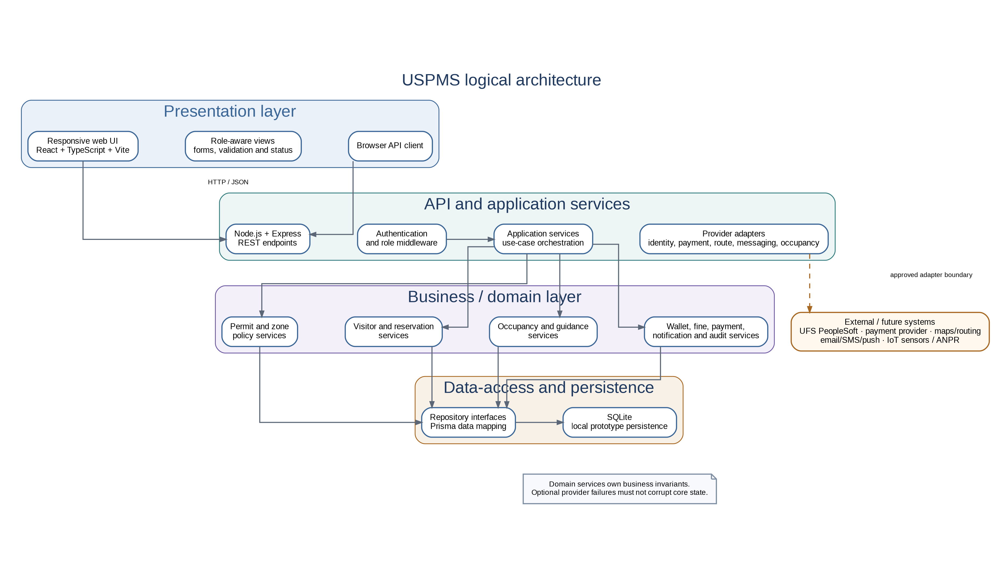

Appendix I — I.2 Core business-layer classes
Core identity, permits, authorisation, visitor reservation and occupancy objects with operations and multiplicities.
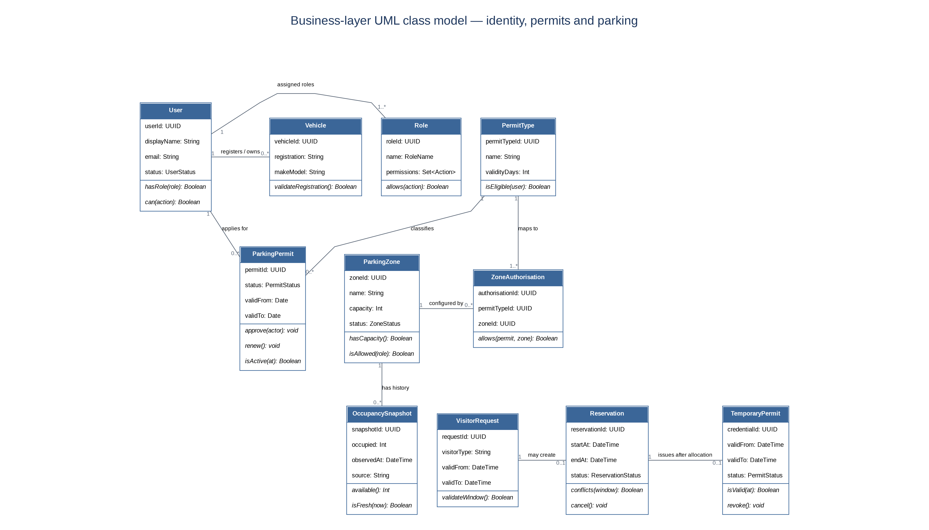

Appendix I — I.3 Supporting business-layer classes
Wallet and ledger, violation/fine/payment, accessibility request, notification, occupancy alert and audit objects.
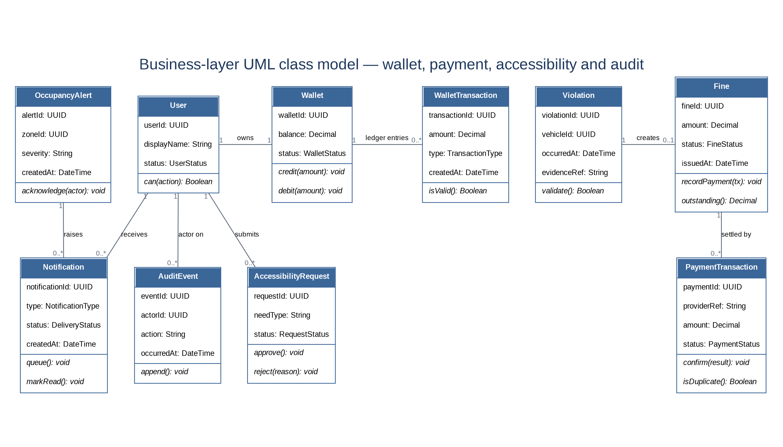

Appendix I — I.4 Sequence — permit lifecycle
Formal UML sequence view showing validation, privileged decision, persistence, audit and notification; alternative paths are noted in the fragment frame.
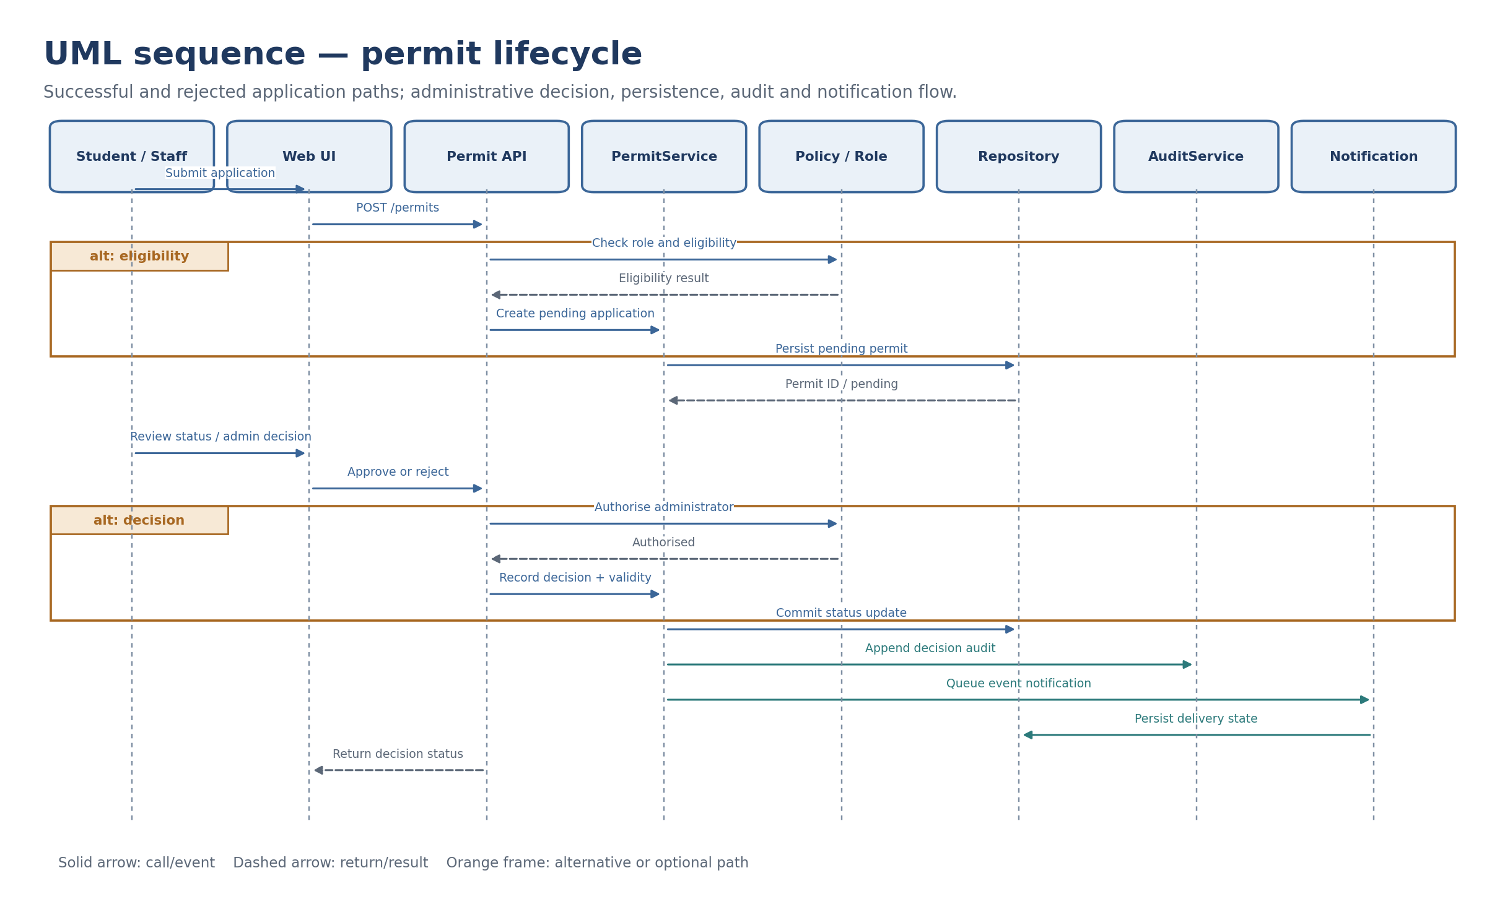

Appendix I — I.5 Sequence — visitor reservation
Formal UML sequence view showing capacity/overlap checks, transactional reservation, bounded temporary credential and cancellation.
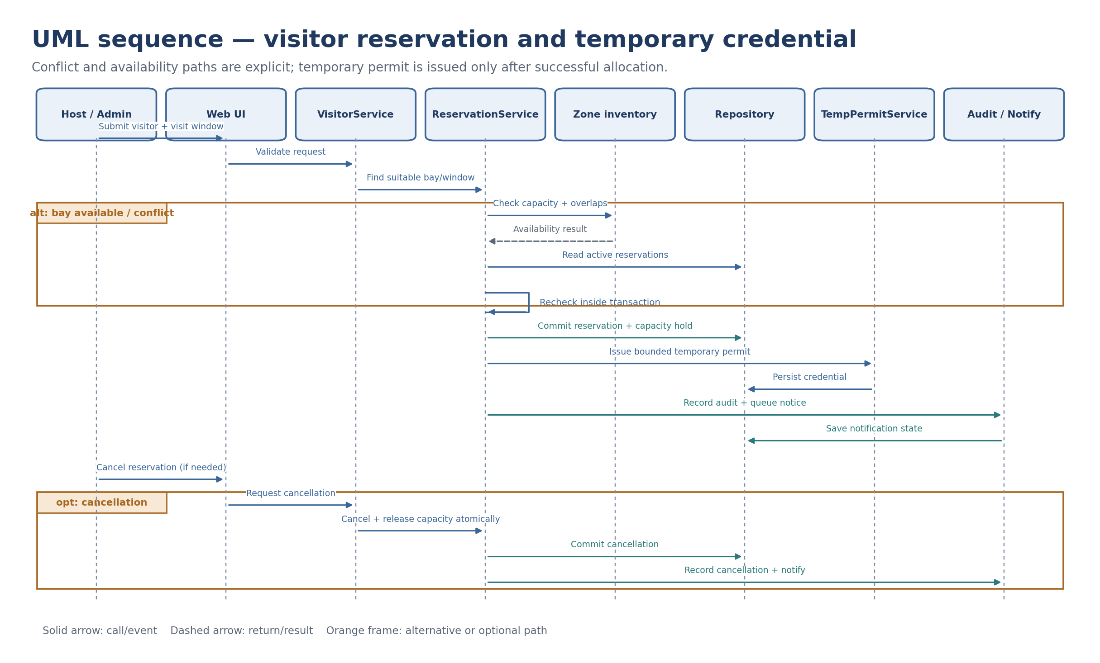

Appendix I — I.6 Sequence — authorised-first guidance
Formal UML sequence view showing credentials and zone authorisation before occupancy ranking, with stale-data and optional-route paths.
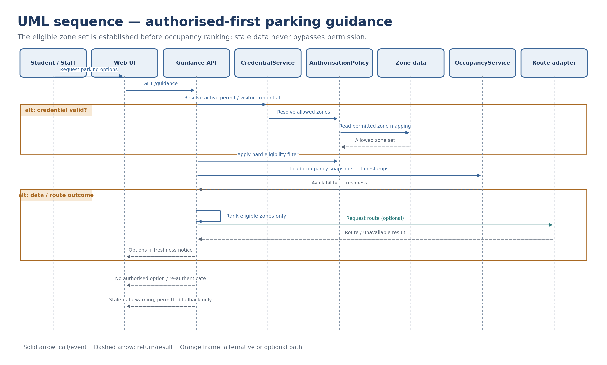
Evidence item | Status in reviewed repository | Required action
Project brief and current scope | Present and reviewed | Retain the brief with the portfolio.
Initial specification / nine use cases | Source artefacts exist | Include original initial version and the final revised specification as separate artefacts.
SPMP and design | Documented here | Team review and approval; keep editable Draw.io source.
Quotation | Mathematically verified; based on estimated hours | Approve/revise hours estimate and quotation before client sign-off.
Actual time record | Team-provided 12-week, six-member record is included in Appendix J and totals 583 hours; it was not independently audited. | Confirm the entries with all six members, retain contemporaneous support where available, and retain member confirmation of Iviwe Faye’s W12 task description.
Source code and repeatable tests | Not present in the inspected original GitHub snapshot. A separate, newly authored reference implementation and its tests are included in this delivery package. | Review and explicitly adopt/port the supplemental reference implementation if suitable; add the original team source if it exists elsewhere.
Dated feedback / meetings / submission receipt | No dated feedback or meeting artefact, or official submission receipt, was found in the inspected original repository snapshot. | Attach actual records if maintained; otherwise state that they were not received.

Appendix J - Team-reported weekly hours register
The following tables reproduce the 12-week record supplied by the team for the period 23 July to 10 October 2026. Weekly hours, categories, recorded session patterns and task descriptions are transcribed from that record. This register is labelled team-reported: the record was not present in the inspected GitHub tree and independent audit or signatures were not supplied with it.

J.1 Consolidated reconciliation
Category | Planned hours | Reported hours | Variance | Basis
Requirements | 60 | 47 | -13 | Logged category as supplied
Specification / Analysis | 105 | 95 | -10 | Logged category as supplied
Design | 80 | 97 | +17 | Logged category as supplied
Implementation | 215 | 194 | -21 | Maps to implementation / integration / validation estimate
Other | 100 | 150 | +50 | Logged category as supplied
TOTAL | 560 | 583 | +23 (+4.1%) | Team-reported total

J.2 Ashley Ashirai Hlatshwayo - Group Leader
Reported total: 105 hours
Week and dates | Recorded sessions | Category | Hours | Tasks recorded
W1  23-26 Jul 2026 | Thu 3h; Sun 2h | Requirements | 5 | Project kickoff, scope boundary definition, stakeholder identification.
W2  27 Jul-02 Aug 2026 | Mon 2h; Thu 3h; Sat 3h | Requirements | 8 | Formalizing problem statement, finalizing 35 functional requirements.
W3  03-09 Aug 2026 | Mon 2h; Thu 3h; Sat 3h | Specification / Analysis | 8 | Reviewing FR/NFR baseline, architectural direction planning.
W4  10-16 Aug 2026 | Mon 2h; Thu 3h; Sun 4h | Specification / Analysis | 9 | Consolidating nine detailed use-case modules.
W5  17-23 Aug 2026 | Mon 2h; Thu 3h; Sat 3h | Design | 8 | High-level logical architecture design, evaluating tech stack.
W6  24-30 Aug 2026 | Mon 2h; Thu 3h; Sun 4h | Other | 9 | Preparing First Portfolio submission, resolving cross-module conflicts.
W7  31 Aug-06 Sep 2026 | Mon 2h; Thu 3h; Sat 3h | Design | 8 | Reviewing business layer class model and sequence diagrams.
W8  07-13 Sep 2026 | Mon 2h; Thu 3h; Sat 5h | Implementation | 10 | Setting up Node.js/Express API environment, reviewing PRs.
W9  14-20 Sep 2026 | Mon 2h; Thu 3h; Sun 4h | Implementation | 9 | Authorisation-first guidance logic integration.
W10  21-27 Sep 2026 | Mon 2h; Thu 3h; Sat 5h | Implementation | 10 | Resolving external integration adapters, merging feature branches.
W11  28 Sep-04 Oct 2026 | Mon 2h; Thu 3h; Sun 5h | Implementation | 10 | End-to-end regression testing, resolving blocker defects.
W12  05-10 Oct 2026 | Mon 2h; Thu 3h; Sat 6h | Other | 11 | Final SPMP review, portfolio assembly, submission readiness checks.
SUBTOTAL |  |  | 105 | Sum of the 12 weekly entries above.

J.3 Anelisa Luxolo Rasi - Project Manager & SPMP Coordinator
Reported total: 98 hours
Week and dates | Recorded sessions | Category | Hours | Tasks recorded
W1  23-26 Jul 2026 | Thu 3h; Sat 1h | Other | 4 | Drafting initial project schedule, setting up GitHub repository.
W2  27 Jul-02 Aug 2026 | Mon 2h; Thu 3h; Sun 2h | Requirements | 7 | Documenting project assumptions, constraints, and risk baseline.
W3  03-09 Aug 2026 | Mon 2h; Thu 3h; Sat 3h | Specification / Analysis | 8 | Mapping Iterative-and-Incremental development strategy.
W4  10-16 Aug 2026 | Mon 2h; Thu 3h; Sun 3h | Specification / Analysis | 8 | Coordinating UML documentation tasks, maintaining meeting log.
W5  17-23 Aug 2026 | Mon 2h; Thu 3h; Sat 3h | Other | 8 | Drafting DevOps plan, blended working plan, and team roles.
W6  24-30 Aug 2026 | Mon 2h; Thu 3h; Sun 3h | Other | 8 | Consolidating First Portfolio files, formatting checks.
W7  31 Aug-06 Sep 2026 | Mon 2h; Thu 3h; Sat 3h | Design | 8 | Tracking design progress against iteration milestones.
W8  07-13 Sep 2026 | Mon 2h; Thu 3h; Sun 4h | Implementation | 9 | Issue tracking, managing GitHub boards, unblocking tasks.
W9  14-20 Sep 2026 | Mon 2h; Thu 3h; Sat 3h | Other | 8 | Updating SPMP estimates, tracking actual hours vs planned.
W10  21-27 Sep 2026 | Mon 2h; Thu 3h; Sun 4h | Implementation | 9 | Coordinating integration test sessions on Google Meet.
W11  28 Sep-04 Oct 2026 | Mon 2h; Thu 3h; Sat 5h | Other | 10 | Finalizing Chapter 3 (SPMP) for Oct 5 draft submission.
W12  05-10 Oct 2026 | Mon 2h; Thu 3h; Sat 6h | Other | 11 | Writing Chapter 5 (Development Effort Overview), final assembly.
SUBTOTAL |  |  | 98 | Sum of the 12 weekly entries above.

J.4 Oratile Thuto Moletsane - Frontend & UI Designer
Reported total: 95 hours
Week and dates | Recorded sessions | Category | Hours | Tasks recorded
W1  23-26 Jul 2026 | Thu 3h; Sat 1h | Requirements | 4 | UI requirement gathering, researching WCAG 2.1 accessibility.
W2  27 Jul-02 Aug 2026 | Mon 2h; Thu 3h; Sat 2h | Specification / Analysis | 7 | Wireframing role-aware navigation and dashboard layouts.
W3  03-09 Aug 2026 | Mon 2h; Thu 3h; Sun 2h | Design | 7 | Designing Permit Wallet and Parking Guidance interface components.
W4  10-16 Aug 2026 | Mon 2h; Thu 3h; Sat 3h | Design | 8 | Mapping UI screens to UC-001 through UC-009.
W5  17-23 Aug 2026 | Mon 2h; Thu 3h; Sun 3h | Implementation | 8 | Initializing React + TypeScript + Vite project, setting up Tailwind.
W6  24-30 Aug 2026 | Mon 2h; Thu 3h; Sat 3h | Implementation | 8 | Building Permit Application and Vehicle Registration UI forms.
W7  31 Aug-06 Sep 2026 | Mon 2h; Thu 3h; Sun 4h | Implementation | 9 | Developing Smart Parking Guidance map views and ranking UI.
W8  07-13 Sep 2026 | Mon 2h; Thu 3h; Sat 3h | Implementation | 8 | Building Admin dashboard for zone management and permits.
W9  14-20 Sep 2026 | Mon 2h; Thu 3h; Sun 4h | Implementation | 9 | Integrating frontend API client with Node.js backend routes.
W10  21-27 Sep 2026 | Mon 2h; Thu 3h; Sat 4h | Implementation | 9 | UI state management for fine payments and notifications.
W11  28 Sep-04 Oct 2026 | Mon 2h; Thu 3h; Sun 4h | Implementation | 9 | Responsive layout fixes, accessibility contrast testing.
W12  05-10 Oct 2026 | Mon 2h; Thu 3h; Sat 4h | Other | 9 | Capturing clean UI screenshots for portfolio evidence.
SUBTOTAL |  |  | 95 | Sum of the 12 weekly entries above.

J.5 Katlego Motala - Requirements Engineer & UML Designer
Reported total: 95 hours
Week and dates | Recorded sessions | Category | Hours | Tasks recorded
W1  23-26 Jul 2026 | Thu 3h; Sun 1h | Requirements | 4 | Defining FR-001 to FR-015, actor identification.
W2  27 Jul-02 Aug 2026 | Mon 2h; Thu 3h; Sat 3h | Requirements | 8 | Finalizing NFRs (Security, Privacy, Usability) and remaining FRs.
W3  03-09 Aug 2026 | Mon 2h; Thu 3h; Sun 3h | Specification / Analysis | 8 | Drafting Use Cases UC-001 to UC-005 in Draw.io.
W4  10-16 Aug 2026 | Mon 2h; Thu 3h; Sat 3h | Specification / Analysis | 8 | Drafting Use Cases UC-006 to UC-009, summary model.
W5  17-23 Aug 2026 | Mon 2h; Thu 3h; Sun 3h | Specification / Analysis | 8 | Writing detailed step-by-step scenarios and postconditions.
W6  24-30 Aug 2026 | Mon 2h; Thu 3h; Sat 3h | Specification / Analysis | 8 | Formatting Chapter 2 specification, checking UML consistency.
W7  31 Aug-06 Sep 2026 | Mon 2h; Thu 3h; Sun 3h | Design | 8 | Converting horizontal sketches to strict UML sequence diagrams.
W8  07-13 Sep 2026 | Mon 2h; Thu 3h; Sat 4h | Design | 9 | Adding alt/opt fragments and lifelines to sequence diagrams.
W9  14-20 Sep 2026 | Mon 2h; Thu 3h; Sun 3h | Implementation | 8 | Assisting backend with API contract alignment to UML.
W10  21-27 Sep 2026 | Mon 2h; Thu 3h; Sat 4h | Implementation | 9 | Validating developed features against FR traceability matrix.
W11  28 Sep-04 Oct 2026 | Mon 2h; Thu 3h; Sun 3h | Other | 8 | Updating Specification Change Register (Appendix F).
W12  05-10 Oct 2026 | Mon 2h; Thu 3h; Sat 4h | Other | 9 | Final traceability matrix audit against codebase.
SUBTOTAL |  |  | 95 | Sum of the 12 weekly entries above.

J.6 Kamogelo Andrew Marumo - Business Analyst & UML Designer
Reported total: 95 hours
Week and dates | Recorded sessions | Category | Hours | Tasks recorded
W1  23-26 Jul 2026 | Thu 3h; Sat 1h | Requirements | 4 | Domain vocabulary definition, identifying core business objects.
W2  27 Jul-02 Aug 2026 | Mon 2h; Thu 3h; Sun 2h | Specification / Analysis | 7 | Drafting BR-01 through BR-15 (Authorisation, Permits).
W3  03-09 Aug 2026 | Mon 2h; Thu 3h; Sat 3h | Specification / Analysis | 8 | Drafting BR-16 through BR-31 (Occupancy, Reservations, Fines).
W4  10-16 Aug 2026 | Mon 2h; Thu 3h; Sun 3h | Design | 8 | Designing initial business-layer class model.
W5  17-23 Aug 2026 | Mon 2h; Thu 3h; Sat 3h | Design | 8 | Separating Wallet, Fine, and Payment into distinct entities.
W6  24-30 Aug 2026 | Mon 2h; Thu 3h; Sun 4h | Design | 9 | Formulating complex algorithms (Section 6.9).
W7  31 Aug-06 Sep 2026 | Mon 2h; Thu 3h; Sat 3h | Design | 8 | Adding typed attributes and multiplicities to class diagrams.
W8  07-13 Sep 2026 | Mon 2h; Thu 3h; Sun 3h | Implementation | 8 | Translating business objects into Prisma ORM schema.
W9  14-20 Sep 2026 | Mon 2h; Thu 3h; Sat 4h | Implementation | 9 | Implementing SQLite local prototype database migrations.
W10  21-27 Sep 2026 | Mon 2h; Thu 3h; Sun 3h | Implementation | 8 | Writing domain service logic for conflict checking.
W11  28 Sep-04 Oct 2026 | Mon 2h; Thu 3h; Sat 4h | Implementation | 9 | Testing data integrity and constraint enforcement.
W12  05-10 Oct 2026 | Mon 2h; Thu 3h; Sat 4h | Other | 9 | Finalizing Chapter 6 (Design Documentation).
SUBTOTAL |  |  | 95 | Sum of the 12 weekly entries above.

J.7 Iviwe Faye - QA, Documentation & Cost Estimation Lead
Reported total: 95 hours
Week and dates | Recorded sessions | Category | Hours | Tasks recorded
W1  23-26 Jul 2026 | Thu 3h; Sun 1h | Other | 4 | Establishing documentation template and file naming conventions.
W2  27 Jul-02 Aug 2026 | Mon 2h; Thu 3h; Sat 2h | Requirements | 7 | Reviewing problem statement and expected benefits logic.
W3  03-09 Aug 2026 | Mon 2h; Thu 3h; Sun 3h | Specification / Analysis | 8 | Proofreading use case narratives and actor descriptions.
W4  10-16 Aug 2026 | Mon 2h; Thu 3h; Sat 3h | Other | 8 | Calculating Chapter 4 Project Quotation based on planned hours.
W5  17-23 Aug 2026 | Mon 2h; Thu 3h; Sun 3h | Other | 8 | Drafting Quality Management Plan and Definition of Done.
W6  24-30 Aug 2026 | Mon 2h; Thu 3h; Sat 4h | Other | 9 | QA review of First Portfolio, reconciling terminology glossary.
W7  31 Aug-06 Sep 2026 | Mon 2h; Thu 3h; Sun 3h | Design | 8 | Verifying logical architecture diagram against documented constraints.
W8  07-13 Sep 2026 | Mon 2h; Thu 3h; Sat 3h | Implementation | 8 | Writing automated unit tests for permit validation.
W9  14-20 Sep 2026 | Mon 2h; Thu 3h; Sun 4h | Implementation | 9 | Executing negative tests (unauthorized zones, stale data).
W10  21-27 Sep 2026 | Mon 2h; Thu 3h; Sat 4h | Implementation | 9 | Manual UI workflow testing against FR/BR acceptance criteria.
W11  28 Sep-04 Oct 2026 | Mon 2h; Thu 3h; Sun 3h | Other | 8 | Compiling Appendix E (Submission Evidence Index).
W12  05-10 Oct 2026 | Mon 2h; Thu 3h; Sat 4h | Other | 9 | Final portfolio assembly, cross-checking page numbers, verifying evidence index, and executing final QA formatting checks for submission.
SUBTOTAL |  |  | 95 | Sum of the 12 weekly entries above.

Appendix K — Supplemental Reference Implementation and Test Evidence
A separate runnable local reference implementation is included under USPMS_Reference_Implementation/ in the delivery ZIP. It was authored specifically for this consolidation task to make selected business rules executable and testable. It is not presented as the original team application, a historical commit, or proof that the recorded July–October team hours were spent on this code.

K.1 Files included
File / location | Purpose
package.json | Node.js package metadata; start, syntax-check and test commands; Node.js 22.5+ requirement.
server.js | Local HTTP API, SQLite schema, synthetic seed data, role checks and demo workflow endpoints.
domain.js | Reusable domain rules for roles, parking availability, occupancy freshness, reservation overlap and fine settlement.
public/index.html, app.js, styles.css | Responsive browser interface for overview, vehicles/permits, guidance, zones, visitors, wallet/fines, accessibility, notifications and audit activity.
test/domain.test.js | 18 domain-level automated tests.
test/api.integration.test.js | 7 API integration tests using a temporary SQLite database.
README.md, test-results.txt | Setup instructions, limitations and recorded execution results.

K.2 Verification results
Check | Result
npm run check | PASS — syntax checks for server.js, domain.js and public/app.js.
npm test | PASS — 25 tests, 25 passed, 0 failed, 0 skipped (10 October 2026, Node.js v22.16.0).
Local HTTP smoke check | PASS — health endpoint, homepage, JavaScript/CSS assets, bootstrap and parking-guidance endpoint responded successfully.
Scenarios exercised | Permit submission/review, role separation, owner boundary, occupancy validation, visitor time-window reservation conflicts, duplicate payment protection, accessibility request/decision and notification acknowledgement.

K.3 Interpretation and limits
These results verify only the newly authored reference implementation. They do not verify a prior team application, live UFS PeopleSoft, payment, map, sensor, ANPR, push/email/SMS or physical gate integrations. The reference interface uses a demo identity selector and synthetic records; it is not production-ready. Its plain HTML/CSS/JavaScript and built-in SQLite approach is distinct from the portfolio’s documented React/TypeScript/Vite + Node/Express + Prisma/SQLite stack. The team must review and approve whether to adopt, port or retain it as a separate reference. Do not add this assistance-created code to the historical 583-hour record.

Final submission readiness and evidence status
The written SPMP and design baseline, editable UML source, team-reported 583-hour record, and a supplemental local reference implementation with a passing automated test suite are included in this delivery package. The original quotation remains separate from the retrospective cost equivalent. The new prototype’s 25 tests passed in this environment; those test results apply only to the supplemental reference implementation, not to an original historical team application or live UFS integrations. Final external verification depends on member confirmation of the time record, team confirmation of whether lecturer/client feedback was received or none was issued, and any original source/build and actual test-result artefacts maintained outside the public GitHub repository if required for marking. Iviwe Faye’s Week 12 task description is included in Appendix J.7 based on the wording supplied for this revision.
Item | Current state in this package | Close-out condition
SPMP and design | Included; planning and design written as a coherent baseline. | Team review and approve scope, architecture and controls.
UML source | Six editable Draw.io pages included. | Confirm diagrams against the final specification and any actual implementation.
Hours record | 583 team-reported hours included; all weekly totals reconcile. | Confirm each member’s entries and retain member confirmation of Iviwe Faye’s W12 task description.
Quotation | Original estimate: R236,670.00; retrospective equivalent: R246,390.38. | Approve estimate basis if a formally issued quotation is required.
Source/build | No original application source or reproducible build was present in the inspected GitHub main branch. A newly authored reference implementation is included in this delivery. | Review/adopt the supplemental code as a reference or add the real original team source and build evidence. Do not represent new code as historical work.
Test results | Appendix K reports 25 passing tests for the supplemental reference implementation. Original historical application test logs were not present in the inspected repository. | Use the included suite for the reference code; attach genuine original application test/build results if that application exists elsewhere.
Lecturer/client feedback | No dated feedback record was located in the inspected source set. | Attach actual feedback and change outcomes, or record a team-confirmed absence.
Repository completeness | The inspected GitHub main branch has five documentation files. The delivery ZIP additionally carries newly authored reference source, tests and setup instructions. | Commit approved/adopted source and evidence to the repository if the team decides the supplemental implementation becomes the project baseline.

